**BIO-DATA**

|  |
| --- |
| **Smt .A.PAVITRA**  **Lecturer in Mathematics**  **Contact No : 9494665254**  Email*: pavitraagadaprolu3@gmail.com* |

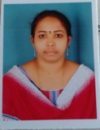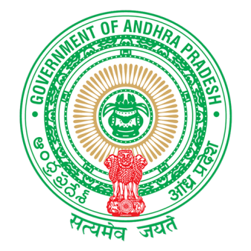

**ACADEMIC QUALIFICATIONS :-**

|  |  |  |  |
| --- | --- | --- | --- |
| **Name of the qualification** | **Name of the Institution** | **% of Marks** | **Year of passing** |
| M.Sc in Mathematics | Andhra University,Vishkapatnam | 85 | 2009 |
| B.Sc.(MPC) | Andhra University,Vishkapatnam | 75 | 2007 |
| Intermediate (MPC) | Govt. Junior College, Narasannapeta | 82 | 2004 |
| S.S.C | Z.P. High School, Narasannapeta | 76 | 2002 |

**TEACHING EXPERIENCE:-**

* Worked as lecturer in Mathematics in S.V.L.N.S. Govt. Degree College,Bhimili,Srikakulam , Dt.from 08/10/2009 to04 /09/2015.
* Working as lecturer in Mathematics in Govt. Degree College ,PALAKONDA, Srikakulam since 08/09/2015 to 07/10/2020.
* Working as a lecturer in Mathematics in Government College for Women (AUTONOMOUS) ,Srikakulam since 08/10/2020 to 24/09/2021.
* Working as a lecturer in Mathematics in Government Degree College, Narasannapeta since 20/10/2021 to till now.

**SEMINARS/WEBINARS/QUIZ/WORKSHOPS/ETC:-**

* One week orientation training for NSS Programming officer’s conducted by Dr B.R.AMBEDHKAR UNIVERSITY ,ETCHERLA,SRIKAKULAM Dist
* Participated in NATIONAL WOMEN PARLIAMENT held at Pavitrasangamam , Amaravathi, AP
* Organized Regional Seminar on Green Concern in Chemical Reaction Sponsered by UGC on 17/08/2016 at GDC, Palakonda ,Srikakulam dist
* Attended as subject expert in JAWAHAR NAVODAYA SCHOOL Teachers recruitment 2016-17.
* Participated in The NATIONAL WEBINAR on ‘BASICS OF MATHLAB’ on 10/12/2021 organised by the Departmant of Mathematics V.K.V.GOVERNMENT DEGREE COLLEGE,KOTHAPETA.
* Attended as NATIONAL LEVEL QUIZ IN MATHEMATICS on the occasion of NATIONAL MATHEMATICS DAY on dec 2021 organised by the Department of Mathematics , V.K.V.GOVERNMENT DEGREE COLLEGE,KOTHAPETA.
* Participated in The NATIONAL WEBINAR ON ‘ WOMEN,S PROTECTION ACTS IN INDIA’ on 07/03/2022 organised by WOMEN EMPOWERMENT CELL & DEPARTMENT OF TELUGU of V.K.V.GOVERNMENT DEGREE COLLEGE,KOTHAPETA.
* Participated on the Online Quiz on ‘INTERNATIONAL PI DAY’ on 14/03/2022 by the Department of Mathematics ,YVNR GOVERNMENT DEGREE COLLEGE, Kaikaluru, Krishna dt.

**ACHIEVEMENTS :**  I got 9th rank in APRCET and I am joined in PH.D on 28/04/2022 by the

MATHEMATICS IN ANDHRA UNIVERSITY,VISHAKAPATNAM.

**PERSONAL PROFILE:-**

|  |  |
| --- | --- |
| **Name** | **A.PAVITRA** |
| **Father’s Name** | A.Narasinga Rao |
| **Date of Birth** | **21/04/1986** |
| **Nationality:** | Indian |
| **Religion:** | Hindu |
| **Marital Status:** | married |
| **Languages Known** | English, Telugu |